American University of Beirut
Department of Geology
Physical Geology – Geol. 201
Exam 1 – Sept. xth 20xx

Part 1- True or false
1. Most rocks are aggregates of minerals.
2. All minerals have a crystal form.

Part 2- Multiple choices
1. Because of their similarity to Earth the inner planets are also called __________.
- Jovian Planets
- Terrestrial planets
- The smallest Planets
- The nearest Planets
2. The gaseous envelope of the earth is called__________.
- Lithosphere
- Atmosphere
- Hydrosphere
- Biosphere

Part 3 – Explanation of figures (2 points each, 16 points total)
- Fill the gaps (A – H) with a proper term:

____H____
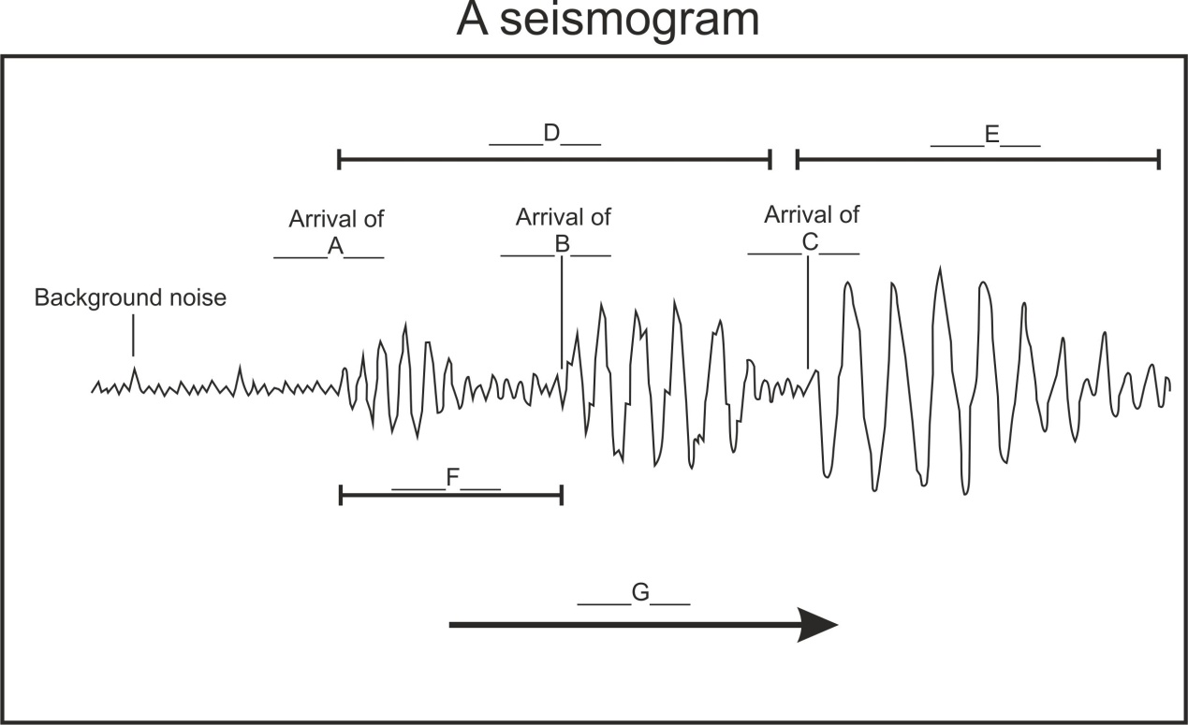
A: B:
C: D:
E: F:
G: H:

Part 4 – Brief Answer

- List all the evidences that support the plate tectonic Theory?

